BUSINESS PARTNER FEATURE: 2,608
This column is devoted to our business partners so we all get to know them better.

Meet the Tinsleys -Joint Venture Partners with HMS Host

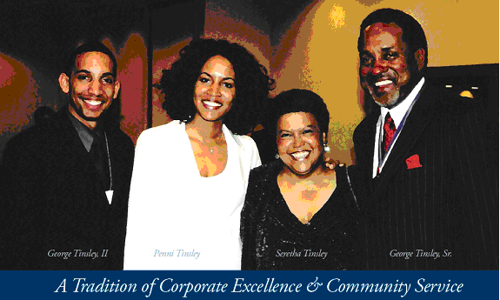
(l-r) George Tinsley II, Penni Tinsley, Seretha Tinsley, G.W. Tinsley Sr.

The Tinsleys, of Tinsley Family Concessions, Inc. have made a personal commitment to both their families and their community to help foster an understanding and awareness of the importance of nourishing the heart and soul each and every day. Over four years ago, the Tinsley’s had the pleasure of the opportunity to do business in the Miami International Airport.

G.W. Tinsley, Sr. (CEO), Seretha (CFO), George II (VP and Managing Partner) and Penni (SEC), are the Officers and Directors of Tinsley Family Concessions, Inc. They are Joint Venture partners with HMSHost in the Miami International Airport and the Tampa Airport. They have been in the concession business for over 12 years and 31 years in the restaurant business, beginning that career path with their company PenGeo, Inc. dba KFC Franchisees, named after George II and Penni.

George Sr. and Seretha, formerly educators, have dedicated their lives to serving the communities they do business in as well as mentoring their many young employees. They own the number three top-grossing KFC franchisee in the State of Florida, and TGIFriday’s (Tampa Airport) in the Nation for eight straight years.

Penni, a graduate of the University of North Carolina at Chapel Hill is currently pursuing a modeling and acting career, having recently appeared on “Good Morning America” and “The Today Show” as well as appearances on several soap operas. Penni has served as FOH Manager in the family concession business and has kept her skills sharpened by working part-time in some of New York’s finest restaurants.

George II, is centered on the restaurant industry. He began his management career while working in KFC through high school. He attended Morehouse College, where he graduated with a major in Business Administration in 2002. Over the last four years, he has been heavily involved in the operations and development of the Host/Tinsley JV business.

“Tinsley Family Concessions appreciates our relationship with our Joint Venture Partner (HMSHost), Miami Dade Aviation Authority, and the Minority Affairs department. We truly believe that our success through the DBE program is a group effort” says George Tinsley II. “We are extremely supportive of the success of the Miami Airport and hope to continue our participation in making it the desired destination of travelers to the South Florida area”.
Picture

